

Prosthetics
View Billing Information (GUI)

User Manual
Patch RMPR*3*96

Version 3.0
January 2005

Revised March 2009

Department of Veterans Affairs
VISTA Health System Design and Development (HSD&D)

Revision History

GUI User Manual | Below are the development phases and dates of this Prosthetics - View Billing Information (GUI) User Manual.

Section | Date | Patch | Page/Author | Change
Section 5 | 03/2009 | RMPR*3.0*149 | Pages 23-26  Tim Dawson | To reflect change in GUI

Table of Contents

View Prosthetics Billing Information User Manual 5
Overview 5
Section 1 - For Billing Users 6
Billing Main Menu Window 6
Section 2 – For Prosthetics Users 7
Prosthetics Main Menu Window 7
Section 3 – View Billing Information Package 8
View Billing Information Window 8
Enter a Date Range 9
Display the Prosthetics Data 11
Change Data Display 12
View Column Descriptions - Site, Dates and Patient Data 13
View Column Description - Insurance Information 14
View Column Descriptions - Coding Errors 15
View Column Descriptions - Item Information 16
View Column Descriptions - Quantity and Total Cost Data 17
View Column Descriptions - HCPCS and HCPCS Description Data 18
View Column Descriptions - ICD9 and ICD9 Description 19
View Column Descriptions - Disability Information 20
Section 4 - Printing 21
Print the View Prosthetics Billing Information Window 21
Section 5 – Saving 23
Save as an Excel File 23
Section 6 - Closing and Exiting 27
Exit the View Prosthetics Billing Information Window 27
Appendix A 28
Getting Help 28
Appendix B 29
Activate Section 508 Assistance 29

View Prosthetics Billing Information User Manual
Overview

Introduction | This View Prosthetics Billing Information User Manual is for Patch RMPR*3*96. This patch provides Prosthetics GUI (graphical user interface) windows for the View Prosthetics Billing Information feature.  The Prosthetics and Billing users will be able to do the following with this patch:  - Search for data and display data by a range of dates.  - Sort and rearrange the view; display data in a custom view.  - Print the display.  - Convert the display into a Microsoft Excel file (for more complex sorting capabilities).

Audience | These Release Notes are geared towards two audiences. The Vista Sign-on window will appear with different functions according to which type of user is accessing the Billing information. The two audiences for this document and the Vista Sign-on window include:  - Billing users – Section 1  - Prosthetics users – Section 2

Data displayed | The data that is displayed on the View Prosthetics Billing Information window includes the following:  - Site  - Create Date  - Delivery Date  - Patient name  - Social Security Number  - Insurance  - Coding Errors  - Item Description  - Quantity  - Total Cost  - HCPCS  - HCPCS Description  - ICD9  - ICD9 Description

Section 1 - For Billing Users
Billing Main Menu Window

Billing Main windows | Below is the Prosthetics Main Menu window where Billing users can first sign-on to VISTA (using the Vista Sign-On button) and then access the View Prosthetics Billing Information window. The Billing users will see a “green dollar sign” icon on the desktop to select the Prosthetics feature.  Note: Please see the Prosthetics Main Menu User Manual for more detail information regarding VISTA Sign-On instructions.

Prosthetics Main Menu | 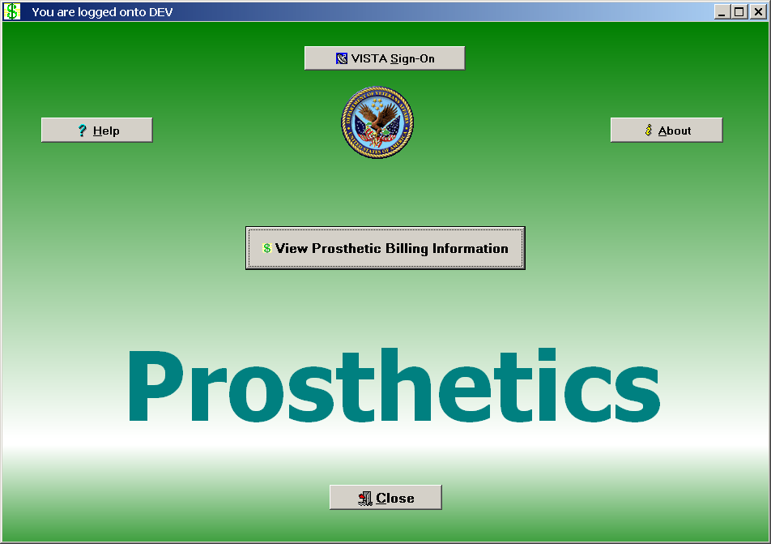

Billing button | Click the View Prosthetics Billing Information button and proceed to Section 3.

Section 2 – For Prosthetics Users
Prosthetics Main Menu Window

Prosthetics Main Menu Window | Below is the Prosthetics Main Menu window where Prosthetics users can sign-on to VISTA and then access the View Prosthetics Billing Information window. These users also have access to other Prosthetics features.  Note: To access this application, you will double click on the Prosthetics VISTA Suite (medicine bag) icon on desktop. Please see the Prosthetics Main Menu User Manual for more detailed VISTA Sign-on instructions.

Prosthetics Main Menu | 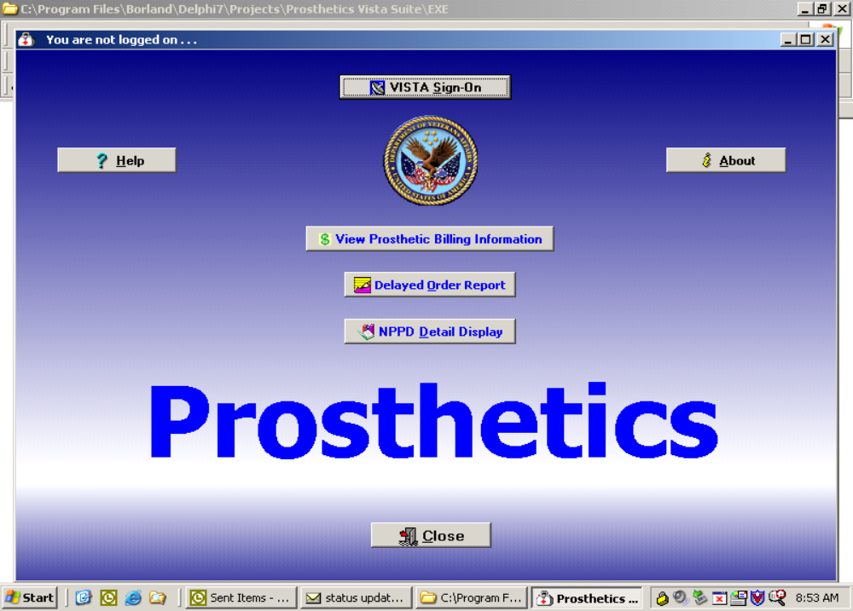

Billing button | Click the View Prosthetics Billing Information button and proceed to Section 3.

Section 3 – View Billing Information Package
View Billing Information Window

Purpose | You can view Prosthetics billing information, insurance information and disability information for specific veteran using the View Prosthetics Billing Information window.

View Prosthetics Billing Information main window | 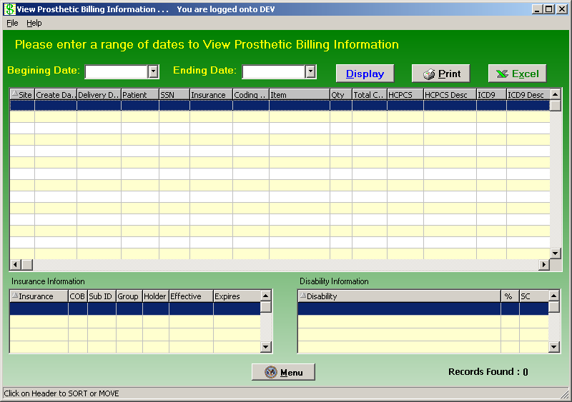

Menu button | The Menu button will close the View Prosthetic Billing Information window and return you to the Prosthetics Main Menu window.

Enter a Date Range

Date/Calendars | After you have successfully signed on to VISTA, and the View Prosthetic Billing Information window appears, you must select the date range that you want to view.  Enter a Beginning Date and an Ending Date by clicking on the drop-down list boxes next to the respective fields. A calendar displays as shown below.  Note: The software will sort by the Create Date field of the Prosthetics Purchase Order or Stock Issue. It does not sort by the Delivery Date field (the date paid).  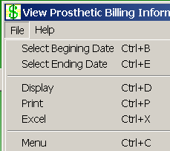  Shortcut: Press the <Ctrl> key + <B> key for the Beginning Date and the  <Ctrl> key + <E> key for the Ending Date to display the respective calendars. You can also click the File Menu and the Select Beginning Date or Select Ending Date option from the list.

Calendar for date range selection | 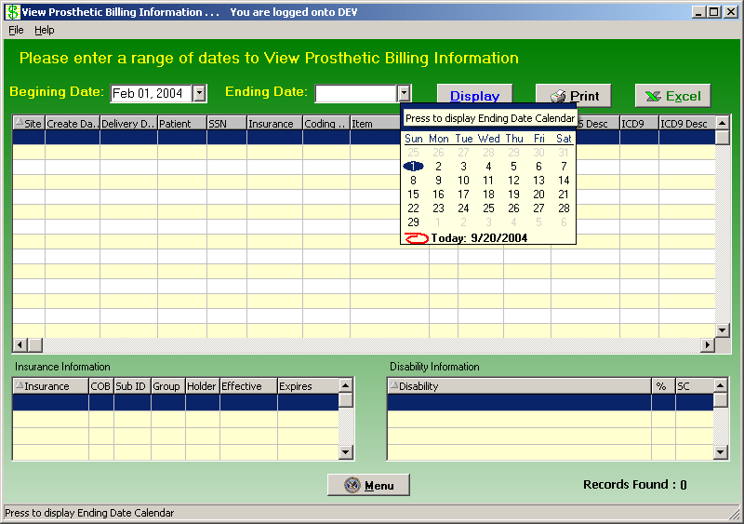

Continued on next page
Enter a Date Range, Continued

Selecting a date range | The calendars display with the current date circled in red shown at the bottom of the calendar. You can accept the current date by clicking on it. You can also change the date by the following methods:

Change the… | Description
Day | Click on the actual day of the week in the calendar.
Month | Click on the month at the top of the calendar to display a list of all months and select one from there. You can decrease or increase one month at a time by clicking the left or right arrows.
Year | Click on the year and an up and down arrow button displays for you to increase or decrease the year.

Number of Day Restrictions | You are restricted to a date range of less than 100 days. If you select a date range outside of this 100 day parameter, the following dialog message box displays:

Date Range Message box | 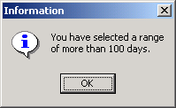

Start Date before End Date | If you accidentally entered an incorrect date range, you will receive a warning message. For instance, if you enter a start date that is after the end date, the message below will display. Click the OK button and reselect your date range.

Start/End Date Message | 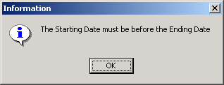

Display the Prosthetics Data

Display the data | Once you have selected the date ranges, click the Display button to reveal the data within that date range. (You can also click the File Menu and the Display option.)  A progress bar activates, and the button name changes to “Searching” while the system is retrieving records. (A long date range may result in a long search time.)  Recommendation: The larger the date range selected, the greater time it will take to search, sort, and display the data. We recommend that you sort by a short date range (5-10 days) and perform the sort early in the morning or later in the day when your VISTA system is less active.  Shortcut: Press the <Ctrl> key + <D> key.

View Prosthetics Billing Information | 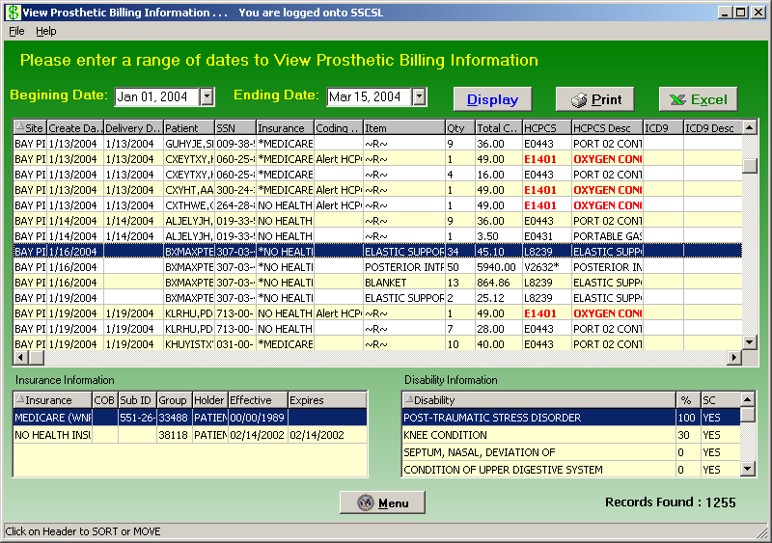

Change Data Display

Changing the display of the data… | You can manipulate the layout of the view in the View Prosthetics Billing Information window for both viewing as well as printing purposes as follows:.  - To enlarge a column, click and drag a cell border.  - To sort on any column, click on the header to sort it in ascending order.  - If you click on the same column again, it will sort it in descending order.

Refresh data | If you have changed the sort order, you can refresh your data by clicking the Display button again.  Note: Refresh does not reset any column resizing that has been done.

View Column Descriptions - Site, Dates and Patient Data

Site | The Site column displays the VA facility where the veteran was treated and where the Prosthetics transaction was created.

Create Date | The Create Date is the date the transaction (Purchase Order or Stock Issue) was created and posted to the Prosthetic veteran’s record (2319).

Delivery Date | If the Delivery Date field is blank, this indicates that Prosthetics has NOT paid the item; therefore an assumption is made that the veteran may not have received the item.  The Delivery Date is not the date the veteran received the item; it is technically the date the Purchase Order was closed or the date the Stock Issue transaction was posted to the 2319.

Patient | The Patient column contains the veteran’s last name and first name. Only Non-Service Connected transactions display for the requested date range.

SSN | The SSN column displays the patient’s Social Security Number (SSN).

Column Headers

View Column Description - Insurance Information

Insurance for a patient | The Insurance column displays health insurance information from the patient’s VISTA record.  If there is no health insurance information in the patient’s VISTA record, it displays “Nothing Found” in the Insurance column.  If health insurance displays, then the most recent insurance entered into the patient’s VISTA record will display.

Insurance column

Asterisk | If there is an asterisk (*) in the Insurance column, this indicates that there is more than one insurance listed for the patient. If there is no asterisk (*), then there is only ONE insurance listed for the patient in the VISTA record.  Click on that line item to display the insurance information in the box below.

Sorting Tip | You can sort on the column headers within the Insurance Information box to group items together for easier review. For instance, you can click on the Effective date column or Expires date column headers, and this will group items for reviewing the most recent insurance.

Effective date column sorted | 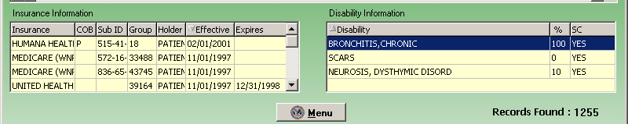

View Column Descriptions - Coding Errors

Coding Errors | The Coding Errors column is to alert Billing users of a possible error. Errors could be any of the following:  - Inactive HCPCS  - Inactive ICD-9 codes  - Use of VA unique HCPCS codes.  The Coding Errors column checks the HCPCS code to see if it was valid at the time of service, and if not, then the word “HCPCS” is shown in red as well as the “HCPCS Description” is shown in red. This also applies to the inactive ICD9 Codes.  Example: If there is a red HCPCS displayed in the HCPCS column, then the Coding Errors column will display “Alert HCPCS” for Prosthetics or Billing users. This will provide a mechanism to alert users to review this billing information.

Coding Column

Sorting Tip | You can sort on the Coding Errors column by clicking the column header to group items for review.

View Column Descriptions - Item Information

Item definition | The Item column displays an Item or appliance kept in the Pros Master Item file. This column displays the IFCAP Item description of the Item issued to the Veteran.

~R~ in the Item column | An “~R~” displayed in the Item column represents a Repair item. The HCPCS Description column should explain what was being repaired.  The Item column is the “Brief Description” entry that is printed on the purchase order transaction and appears on the 2319 record. The Brief Description is entered to define the item.  Tip: You can sort on the Item column by clicking the column header to group items to review all Repair items together.

Item column sorted – Repair items grouped together | 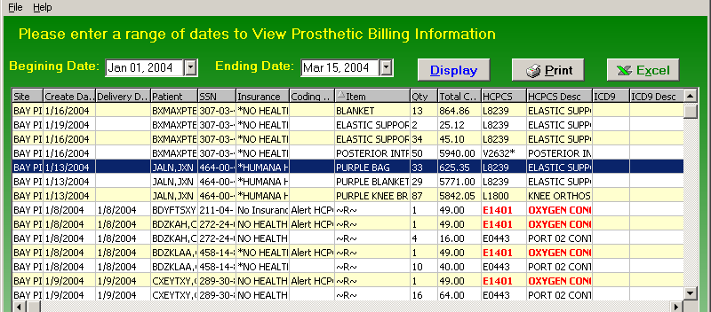

View Column Descriptions - Quantity and Total Cost Data

Qty column | The Quantity column provides the number issued of that Item to the veteran. This is the quantity based on purchasing (not units).  Note: For Home Oxygen, it is a payment unit not a billing unit.

Column headers

Total Cost column | The Total Cost column represents the cost of the issue.

View Column Descriptions - HCPCS and HCPCS Description Data

HCPCS definition | The HCPCS acronym stands for Healthcare Financing Administration Common Procedure Coding System. The HCPCS code represents an item or service. The Prosthetics staff selects the HCPCS code when the transaction was created.

Red HCPCS | If the HCPC Code and HCPCS Description in the HCPCS and HPCPS Description columns are red, that represents a HCPCS Code that has a coding error as defined by an Inactive HCPCS.  This provides an alert to Prosthetics and Billing users as this will affect billing information.

Column headers

Asterisk in HCPCS column and Calculation Flag | If there is an asterisk in the HCPCS column, this indicates that there is a calculation flag.  A calculation flag determines whether or not a HCPCS is used as a Main Component to display the entire cost of a purchase, when multiple items within the purchase make up a whole (e.g., when purchasing a limb or surgical implants).

View Column Descriptions - ICD9 and ICD9 Description

ICD9 definition | International Classification of Diseases (Ninth Revision) -A coding system designed by WHO, (World Health Organization). ICD-9-CM is the official system of assigning codes to diagnoses and procedures associated with hospital utilization in the United States.  The ICD –9 is used to code and classify mortality data from death certificates. VOLUMES 1-2 contain diagnosis and procedures. VOLUME 3 is used for statistical, research and re-imbursement purposes.

Column headers

ICD9 Code Selection | This code is selected by the prescribing clinician when the Prosthetic consult is created.

View Column Descriptions - Disability Information

Disability Information | If the patient has disability information, it will automatically be displayed in the Disability Information box in the bottom of the window.  If a patient is selected without any disability information, the Disability Information box at the bottom of the window will display “Nothing Found.”

Disability sample

Section 4 - Printing
Print the View Prosthetics Billing Information Window

Print the data | You can print the View Prosthetics Billing Information data after you have finished your sort by column heading. Click the Print button to send this information to your local printer, and click OK on the Print dialog box. (You can also click the File Menu and the Print option.)  Note: The layout of the print will be the same as the display. You can select a specific printer to print the View Prosthetics Billing Information window.

Change to Landscape | Recommendation: You should change the format of the printout from Portrait to Landscape to print all the columns on the same page.

Steps | To change the print format, follow these steps:

Step | Action
1 | Click the Print button on the View Prosthetics Billing Information window.
2 | Click the Properties button (to the right of the Name field) on the Print dialog box. Continue to the next page.  Shortcut: Press the <Alt> key + <P> key.

Print dialog box | 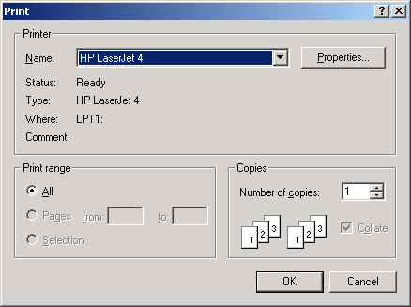

Continued on next page
Print the View Prosthetics Billing Information Window, Continued

Layout Tab | You can change the format of the printout from the standard Portrait format to Landscape on the Layout tab.

Steps (continued) | To continue to change to the Landscape format, follow these steps:

Step | Action
3 | Click the Layout tab on the Properties dialog box (usually shown as a default view).
4 | Click the Landscape radio button to change the format.  Shortcut: Press the <Alt> key + <L> key.
5 | Click OK or press <Enter.>

Landscape Radio button | 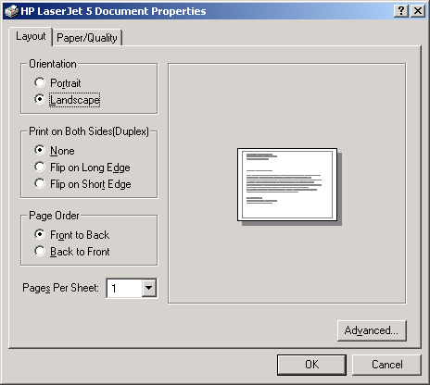

Last step | When you return to the Print dialog box, click OK again, and it will print your output. You can print multiple copies if necessary.

Section 5 – Saving
Save as an Excel File

Excel Button | Click the Excel button on the View Prosthetics Billing Information window to launch Excel and display the current data. (You can also click the File menu and select the Excel option.)  Shortcut: Press the <Alt> key + <X> key to launch MS Excel.  Note: This feature creates a temporary Excel .CSV file in the folder selected. The default folder is C:\ViewBillingDownload (which is automatically created). The file name is based on the date range.  Example: Jul 02, 2006_Aug 10, 2006.csv  Prior to the display, you are notified that the information about to be exported may contain Patient Identifiable Information.

Steps | To export data to Excel:

Step | Action
1 | Click the Excel button on the View Prosthetics Billing Information window.  Shortcut: Press the <Alt> key + <X> key.
2 | Click the OK button on the security reminder.
3 | Continue to the Select Directory window.

Security Reminder | 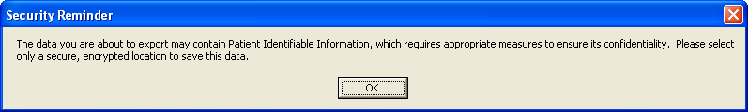

Step | Action
4 | Navigate to the desired directory and select OK .(Click Cancel to exit or Help to view the help pages associated with this functionality)

Select Directory | 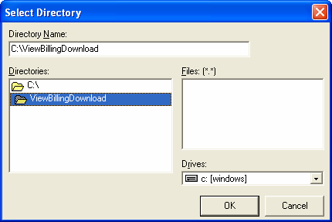

Step | Action
5 | Navigate to a secure location where the temporary Excel (.csv) file will be stored and then select OK . Excel will open and display the data.

Cont’d.

MS Excel data | 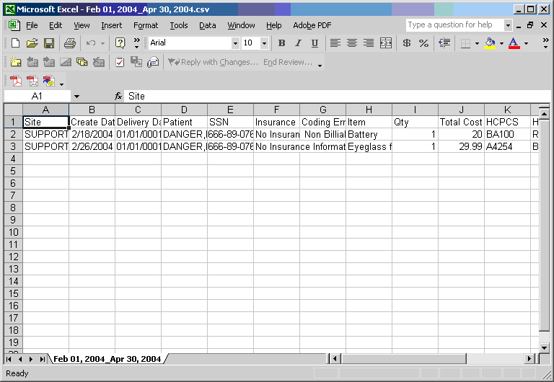

Step | Action
6 | This is only a temporary file so if you wish to save the data you must select File, then Save As, then change the name of the file.  Note: To save the file, you must change the filename from the default. If you accept the default file name, it will be deleted when you close the NPPD window.

Temp file location | Should you wish to check the location of the temp file, it displays on the View Prosthetic Billing window right above the Excel button.  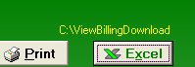
**Note** | You will be unable to export another report to Excel or navigate away from the View Prosthetic Billing Information window until the current Excel (.csv) file is closed. Attempting to do so without first closing the file will result in one of the following errors depending on what action has taken place. If you do save a file with Patient Identifiable Info in it, don’t forget to delete it when you no longer need it.

Attempting to Open another report with temp file still open | 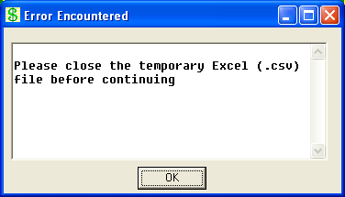

Attempting to navigate away from the View Prosthetic Billing Information window with temp file still open | 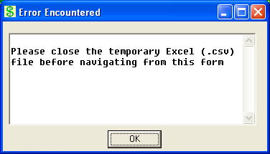

Section 6 - Closing and Exiting
Exit the View Prosthetics Billing Information Window

Exit the Application | You can exit the application by first clicking the Menu button on the View Prosthetics Billing Information window. Then click the Close button on the Main Prosthetics window:

Confirmation window | 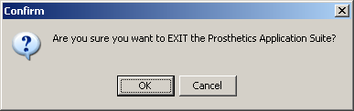

Cancel button | If you click the Cancel button, you will remain in the application and can continue to work.

Appendix A
Getting Help

F1 Key | Online Help can be accessed in three methods:  - Click the Help Menu (located in the upper left corner of the menu bar) and the Contents option.  - Press the <F1> key.  - Press the <Alt> key + <H> key. (This activates the Help Menu, not the Billing contents.)

Help Menu | 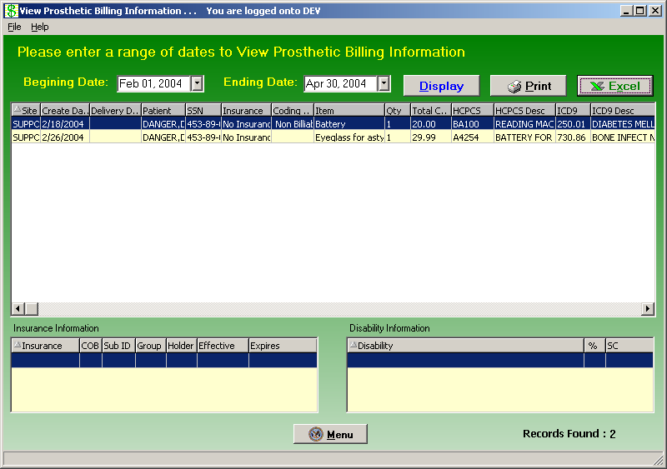

Appendix B
Activate Section 508 Assistance

Introduction | You can change the colors of the screen to black/white, which is required for Section 508 requirements to be read by visually and hearing impaired veterans.  This feature can be updated from the Help Menu. It provides a toggle to go back and forth between using the colors or the black/white screens depending on your needs.

Steps | To activate the Section 508 assistance, follow these steps:

Step | Action
1 | Click the Help Menu, and click the Section 508 option.  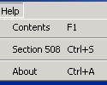  Shortcut: Press the <Ctrl> key + <S> key.
2 | Click OK on the confirmation message dialog box as shown below.
3 | Click OK again to exit out of the system and restart to activate the changes.

Confirmation message | 